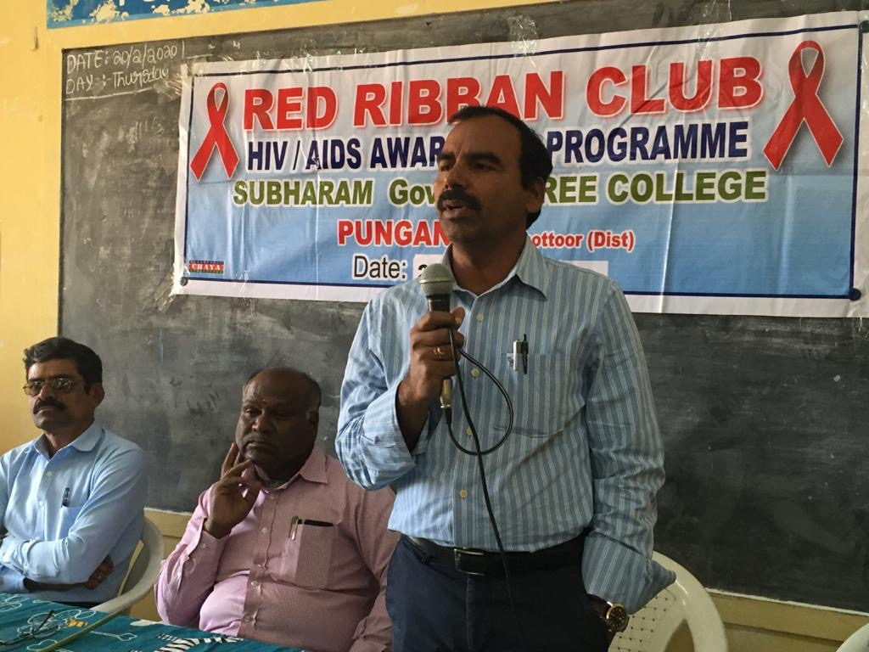
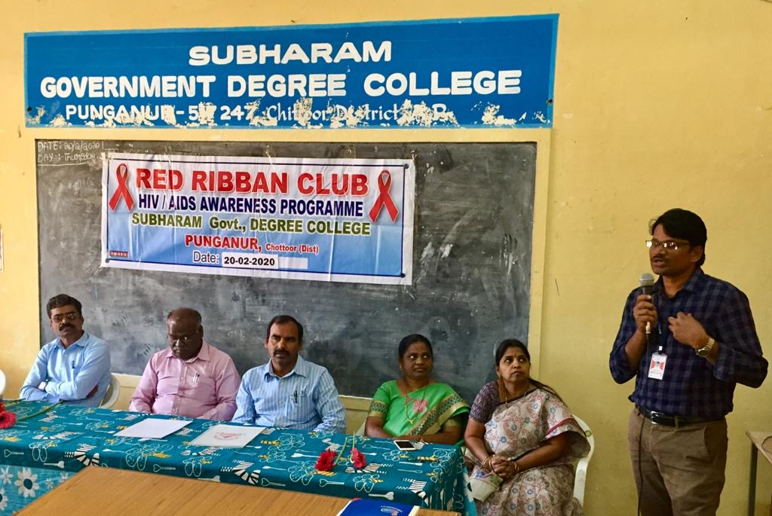
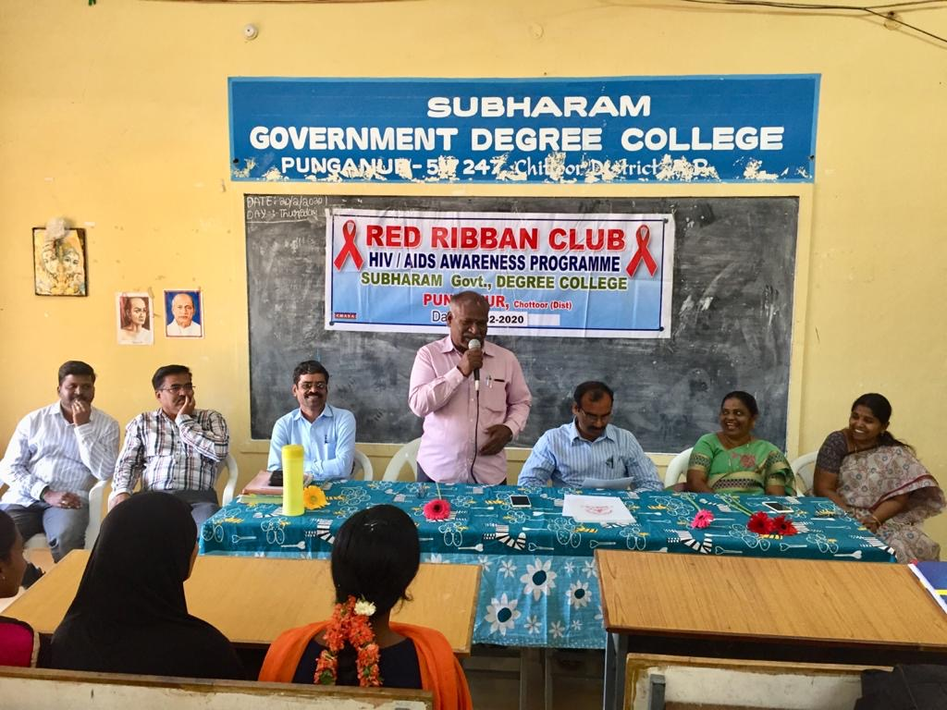
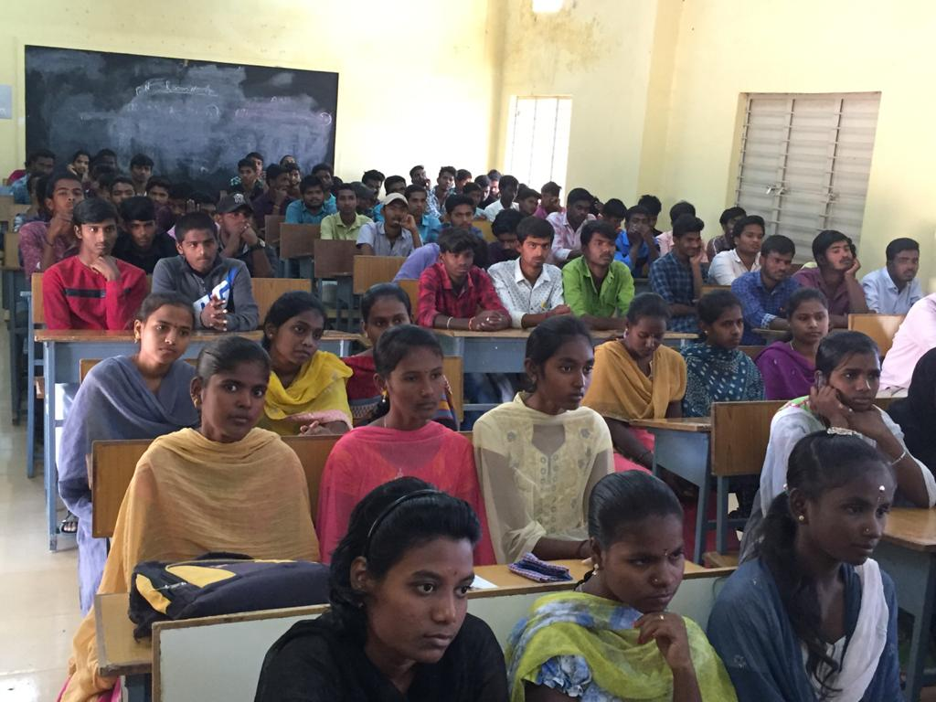
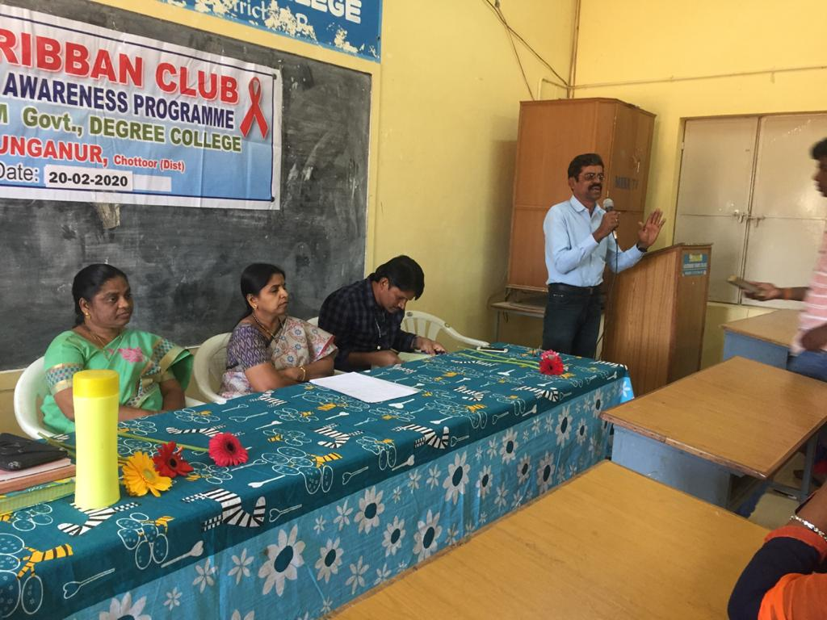
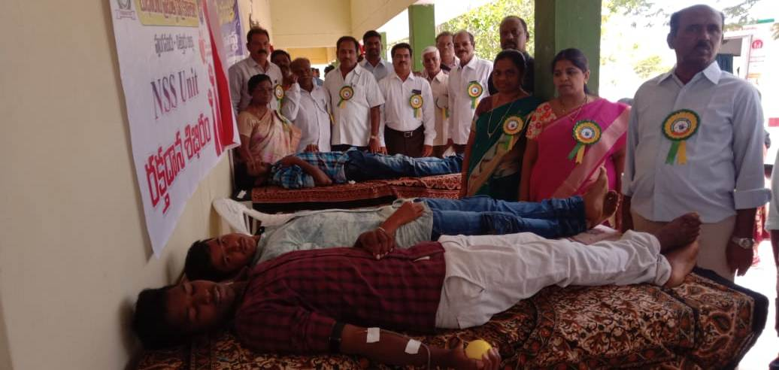

Coordinator: M.Anjaneya Reddy Lecturer in History
Out of 2.47 million estimated population infected by HIV in India, 88.7% are in the age group of 15-49 years. In view of this, Ministry of Health & Family Welfare, Govt. of India has proposed to establish a network with Universities and educational institutions to generate awareness regarding HIV & AIDS and to promote Voluntary Blood Donation to ensure safe blood and implement preventive programmes on HIV & AIDS.
Under the NACP III youth have been identified as a vulnerable group requiring special attention. Recognizing the heterogeneity of the youth NACP III aims to promote Red Ribbon Clubs to cover youth at risk to HIV both in campuses as well as in community.
Through RRC youth are encouraged to learn about safe and healthy lifestyles. The RRC promotes access to information on safe sexual behaviors and voluntary blood donation as well as enable them to become change agents in HIV & AIDS programme.
To create and provide opportunity to the zeal of volunteerism among youth to contribute towards the control and prevention of HIV&AIDS Red Ribbon Club in the S.G. Government Degree College, PILER was formed.
The Red Ribbon Club is a voluntary on-campus intervention program for students in the College. It is initiated and supported by the State AIDS Control Society (APSACS) and implemented through Commissioner of Collegiate Education and using the services of National Service Scheme (NSS).
The programme will address the knowledge, attitude and behavior of the youths in the interrelated areas of Voluntary Blood Donation, HIV & AIDS and sexuality, as demanded by their age, environment, and life style. The, Red Ribbon Club will serve as a complementary and comprehensive prevention intervention to support and reinforce similar youth led initiatives.
Thus Red Ribbon Club Programme (RRCP) is a comprehensive promotional and preventive intervention to enhance voluntary blood donation as well as mainstream HIV & AIDS prevention, care & support and treatment impact, mitigation, stigma reduction, among the youth in educational institutions. It will also prepare and promote youth peer educators within and outside the campuses.
The RRC aims at harnessing the potential of the youth by equipping them with correct information on HIV/AIDS Prevention, Care and Support and Treatment. It also aims in building their capacities as peer educators in spreading messages on positive health behaviors in an enabling environment and increasing voluntary blood donation from among youth.

